* Copyright for test papers and marking guides remains with *West Australian Test Papers*.
* The papers may only be reproduced within the purchasing school according to the advertised conditions of sale.
* Test papers must be withdrawn after use and stored securely in the school until, 16th June.

**PHYSICS**

**UNIT 1**

**2022**



Name: _______________________________________________________

Teacher: ___________________________________________________

***TIME ALLOWED FOR THIS PAPER***

Reading time before commencing work: Ten minutes

Working time for the paper: Two hours 30 minutes

***MATERIALS REQUIRED/RECOMMENDED FOR THIS PAPER***

**To be provided by the supervisor:**

* This Question/Answer Booklet
* Formula and Data Booklet

**To be provided by the candidate:**

* Standard items: pens (blue and black preferred), pencils (including coloured), sharpener, correction fluid/tape, eraser, ruler, highlighters.
* Special items: up to three calculators, which do not have the capacity to store programmes or text, are permitted in this ATAR course examination, drawing templates, drawing compass and a protractor.

***IMPORTANT NOTE TO CANDIDATES***

No other items may be taken into the examination room. It is **your** responsibility to ensure that you do not have any unauthorised material. If you have any unauthorised material with you, hand it to the supervisor **before** reading any further.

**Structure of this paper**

|  |  |  |  |  |  |
| --- | --- | --- | --- | --- | --- |
| Section | Number of questions available | Number of questions to be answered | Suggested working time  (minutes) | Marks available | Percentage of exam |
| Section One:  Short answer | 10 | 10 | 50 | 53 | 30 |
| Section Two:  Extended answer | 6 | 6 | 80 | 81 | 50 |
| Section Three:  Comprehension  and data analysis | 2 | 2 | 20 | 31 | 20 |
|  |  |  | **Total** | 165 | 100 |

**Instructions to candidates**

1. The rules for the conduct of Western Australian external examinations are detailed in the *Year 11 Information Handbook 2022: Part II Examinations.* Sitting this examination implies that you agree to abide by these rules.
2. Write your answers in this Question/Answer booklet preferably using a black/blue pen. Do not use erasable or gel pens.
3. You must be careful to confine your answers to the specific questions asked and follow any instructions that are specific to a particular question.
4. When calculating or estimating answers, show all your working clearly. Your working should be in sufficient detail to allow your answers to be checked readily and for marks to be awarded for reasoning.

In calculations, give final answers to three significant figures and include appropriate units where applicable.

In estimates, give final answers to a maximum of two significant figures and include appropriate units where applicable.

1. Supplementary pages for planning/continuing your answers to questions are provided at the end of this Question/Answer booklet. If you use these pages to continue an answer, indicate in the original answer where the answer is continued, ie – give the page number.
2. The Formulae and Data booklet is not to be handed in with your Question/Answer booklet.

**Section One: Short response 30% (53 Marks)**

This section has **ten (10)** questions. Answer **all** questions. Write your answers in the space provided.

When calculating numerical answers, show your working and reasoning clearly. Give final answers to **three** significant figures and include appropriate units where applicable.

When estimating numerical answers, show your working and reasoning clearly. Give final answers to a maximum of **two** significant figures and include appropriate units where applicable.

Supplementary pages for planning/continuing your answers to questions are provided at the end of the Question/Answer booklet. If you use these pages to continue an answer, indicate at the original answer where the answer is continued, ie – give the page number.

Suggested working time for this section is 50 minutes.

**Question 1 (6 marks)**

A balloon contains helium gas and nitrogen gas. The gases are at a common temperature of 25°C.

1. Describe the relative speeds of the gas particles. Explain your answer.

(3 marks)

______________________________________________________________________________________________________________________________________________________________________________________________________________________________________________________________________________________________________________________________________________________________________________________________________

1. The gases are heated to 50°C. Describe any change you would expect to notice in the balloon. Explain your answer using the Kinetic Theory.

(3 marks)

______________________________________________________________________________________________________________________________________________________________________________________________________________________________________________________________________________________________________________________________________________________________________________________________________

**Question 2 (6 marks)**

A worker in a uranium mine is exposed to three different types of radiation: alpha, beta and gamma. The worker has a mass of 95.5 kg and absorbs 10.7 J of ionising radiation. The worker estimates that 25.0% of this is due to alpha radiation; 30.0% due to beta radiation; and 45.0% due to gamma radiation. It is assumed that this is a full-body exposure.

1. Calculate the dose equivalent the worker received.

(4 marks)

____________ Sv

1. During their line of work, workers in uranium mines have dust from minerals landing on their clothing that emit all three types of radiation: alpha, beta and gamma. Which of these emissions do they need most protection from? Explain.

(2 marks)

________________________________________________________________________________________________________________________________________________________________________________________________________________________________________________________________________________________________________________________

**Question 3 (5 marks)**

Calculate the binding energy per nucleon of the calcium-40 atom in eV. Use the masses provided in the table to assist you.

|  |  |
| --- | --- |
| **Name** | **Mass of atom**  **(u)** |
| Proton | 1.007 276 |
| Neutron | 1.008 665 |
| Electron | 0.000 548 58 |
| Hydrogen | 1.007 825 |
| Calcium-40 | 39.962591 |

**Question 4 (6 marks)**

An aluminium kettle of mass 1.05 kg contains a quantity of water at a room temperature of 23.0 °C. The kettle has a power rating of 1.80 x 103 W and it takes 2.00 minutes to raise the temperature of the water to 75.0 °C. Assuming no heat is lost to the surroundings, calculate the mass of the water in the kettle.

[Specific heat capacity of aluminium = 904 J kg-1 °C-1]

_____________ kg

**Question 5 (5 marks)**

For the following scenarios, write a balanced nuclear equation.

(a) Americium-241 emits an alpha particle.

(1 mark)

(b) Strontium-90 has too many neutrons and decays to yttrium-90.

(1 mark)

(c) Uranium-235 captures a thermal neutron and splits into zirconium-103, tellerium-131 and several neutrons.

(2 marks)

(d) Hydrogen-2 and hydrogen-1 can fuse to form a gamma ray and helium-3.

(1 mark)

**Question 6 (4 marks)**

Consider the three thermometers below sitting in a room where the air temperature is 24.0 ⁰C. One of the thermometer’s bulbs is covered in a cloth soaked in water, one is covered in a cloth soaked in isopropyl alcohol (a volatile solvent that readily evaporates) and the other is left open. A fan blows the air across the 3 thermometers.

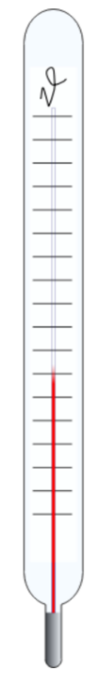

Open Isopropyl Water

Bulb

(a) In the table below. Place any of the values into the table that would best represent the temperatures of the 3 thermometers after a brief time period.

(1 mark)

Options: 30 ⁰C 24 ⁰C 16 ⁰C 18 ⁰C 28 ⁰C

|  |  |  |  |
| --- | --- | --- | --- |
|  | **Open** | **Isopropyl alcohol** | **Water** |
| **Temperature** |  |  |  |

(b) Explain why the thermometer soaked in water has a different final temperature to the open thermometer.

(3 marks)

**Question 7 (4 marks)**

Jenny loves a cup of iced tea - and she likes it being ice cold. On a particular day, she brews a pot of tea which contains 0.255 kg of water at 90.0°C. She keeps adding ice at 0.00°C until the water reaches 2.00°C. The pot can be assumed to have no thermal properties and no heat is lost to the surroundings. Calculate the mass of ice that must be added to the water to achieve this.

___________kg

**Question 8 (5 marks)**

Polonium-218 is an alpha emitter. During this transmutation, it produces the isotope lead-214.

The atomic masses of the particles involved in this decay are:

Po-218: 218.008966 u

Pb-214: 213.999805 u

He-4: 4.002603 u

1. Write a balanced nuclear equation for this alpha decay.

(2 marks)

1. Calculate the energy released (in MeV) during this decay.

(3 marks)

__________ MeV

**Question 9 (6 marks)**

A student measures the activity of a radioisotope over a 12-minute period. He obtains the graph below.

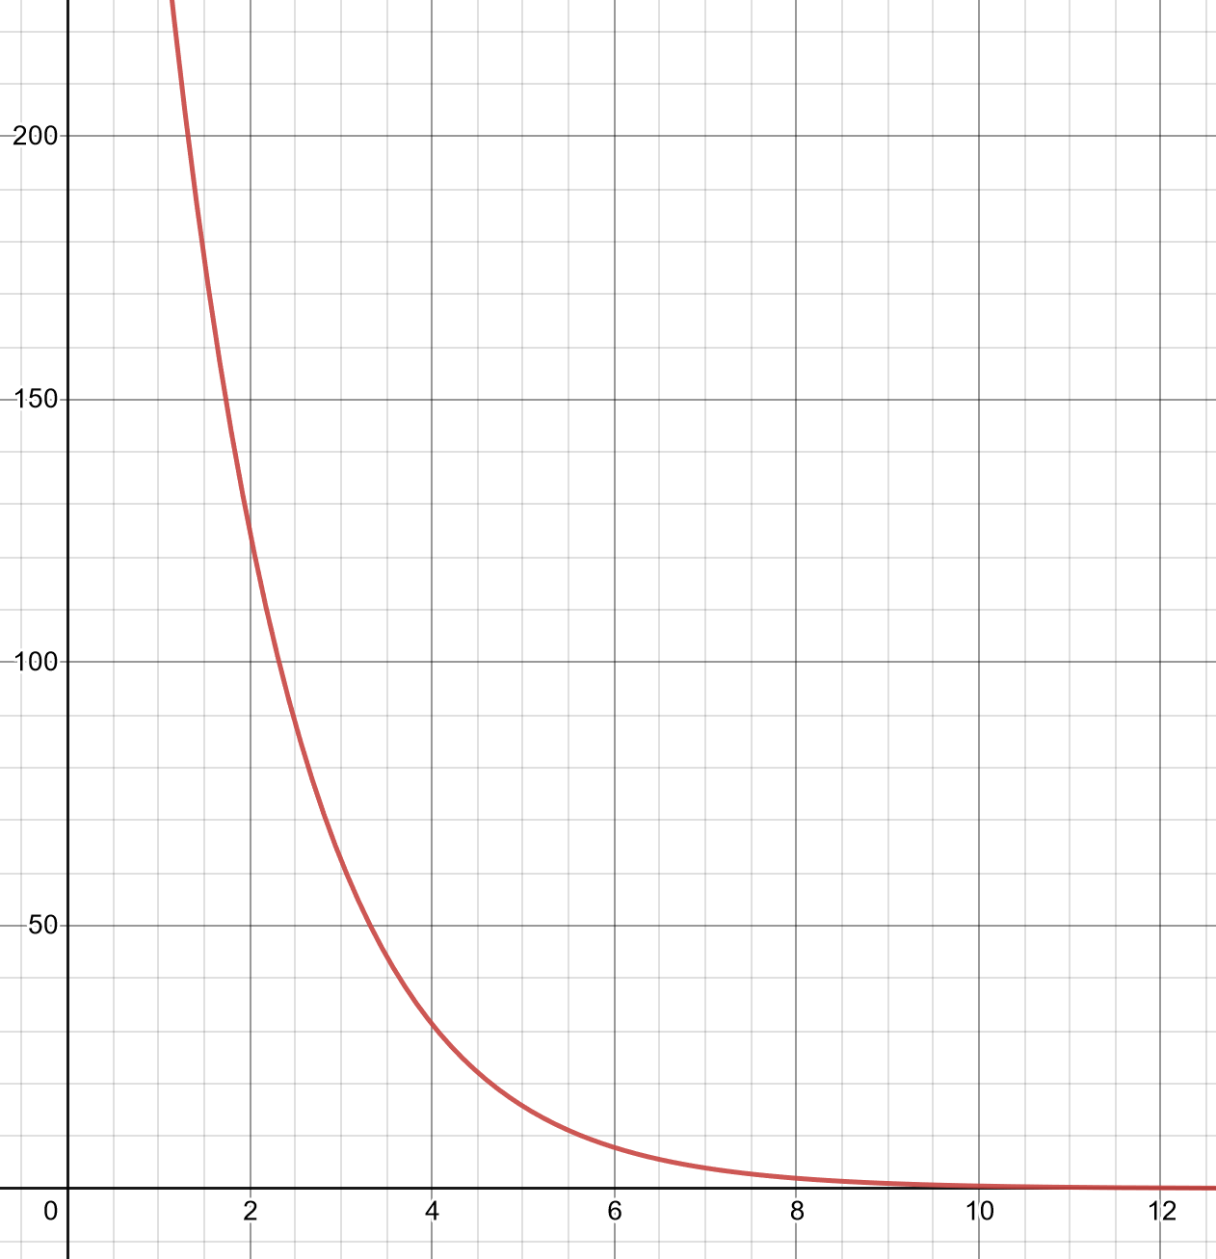

Time (min)

Activity (Bq)

1. Making use of the graph above, determine, with two separate calculations, the average

half-life of the sample.

(3 marks)

(b) Given the initial activity of the sample was 500 Bq, calculate the time taken for the activity to drop to 62.5 Bq.

(3 marks)

**Question 10 (6 marks)**

Water is being heated in a metal pan on an electric heating element as shown below. The handle for the pan is covered in hard plastic.

Water

Metal pan

Handle

Electric heating element

1. State the form of heat transfer that is primarily responsible for the electric heating element initially heating the water.

(1 mark)

________________________________________________________________________

1. In terms of heat transfer, explain why the handle of the pan is made of plastic.

(2 marks)

________________________________________________________________________________________________________________________________________________________________________________________________________________________________________________________________________________________________

1. It is found that placing a lid over the pan allows the temperature of the water to rise more quickly. In terms of heat transfer, explain why this is the case.

(3 marks)

________________________________________________________________________________________________________________________________________________________________________________________________________________________________________________________________________________________________________________________________________________________________________________________________________________________________________________

**End of Section One**

**Section Two: Problem-solving 50% (81 Marks)**

This section has **five (5)** questions. You must answer **all** questions. Write your answers in the space provided.

When calculating numerical answers, show your working and reasoning clearly. Give final answers to **three** significant figures and include appropriate units where applicable.

When estimating numerical answers, show your working and reasoning clearly. Give final answers to a maximum of **two** significant figures and include appropriate units where applicable.

Supplementary pages for planning/continuing your answers to questions are provided at the end of the Question/Answer booklet. If you use these pages to continue an answer, indicate at the original answer where the answer is continued, ie – give the page number.

Suggested working time for this section is 90 minutes.

**Question 11 (16 marks)**

A group of students are conducting an experiment to determine the solar constant ”P”; the rate at which energy reaches the Earth's surface from the Sun measured in W. They use a solar box which has a matte black surface and is filled with 0.0300 kg of conductive oil (c = 0.950 x103 J kg-1 K-1). The solar box has an instruction manual that contains the following information:

|  |  |
| --- | --- |
| **Time**  **(minutes)** | **Temperature**  **(ºC)** |
| 0 | 20.0 |
| 4 | 20.3 |
| 8 | 21.6 |
| 12 | 23.3 |
| 16 | 25.0 |
| 20 | 26.5 |
| 24 | 28.0 |
| 28 | 29.6 |
| 32 | 31.2 |
| 36 | 32.1 |
| 40 | 32.3 |
| 44 | 33.9 |
| 48 | 35.5 |

T = 21.0 ºC

*In full sunlight, the SOLAR BOX is able to absorb 90.0 % of all incident thermal radiation (to a maximum of 55.0 ºC).*

*Note: an initial time lag of approximately 4 minutes will pass before a constant rate of transfer occurs.*

The students decide to place the solar box out in the sun and record the temperature with a data logger and stop recording if the temperature reaches 55.0 ºC. Their data is shown in the table to the left.

(a) On the graph on the following page, plot a graph of temperature vs time. Do not draw a line of best fit yet. A spare grid is provided on the end of this Question/Answer booklet. If you need to use it, cross out this attempt and clearly indicate that you have redrawn it on the spare page.

(4 marks)



While waiting for the data to be collected, the students derive an equation relating the solar constant power to the graph they intend to construct.

$$P=66.7mc×\frac{∆y}{∆x}$$

Where P is the Solar constant, m is the mass of oil and c is the specific heat capacity of the oil.

(b) Show how the students were able to derive an equation relating the variables shown above.

(4 marks)

Between 32 minutes and 40 minutes an anomaly occurred which produced unreliable data. The

students decided to exclude the data after 32 minutes as well as the first 4 minutes.

(c) Using this information, draw a line of best fit and determine the gradient of this region. Express your answer to 2 significant figures.

(5 marks)

(d) Use the gradient and the equation provided to estimate the solar constant.

(3 marks)

**This page has been left blank intentionally**

**Question 12 (14 marks)**

Whilst making a cup of coffee, 355 mL of hot water is added to a 320.0 g ceramic coffee mug. Both reach a common temperature of 90.0°C.

It is known that water at this temperature can cause third degree burns, so a decision is made to cool it down to 55.0 °C. This is achieved by adding ice at -8.50 °C until this final cooler temperature is achieved.

Assume no heat is transferred to the surroundings.

1. Show that the heat energy lost by the water and the ceramic mug as their temperature drops to 55.0 °C is approximately 7.00 x 104 J.

The specific heat capacity of ceramic is 1.49 x 103 J kg-1 °C-1.

(3 marks)

__________ J

1. The mass ‘m’ of the ice added is unknown. In terms of ‘m’, calculate the thermal energy gained by the ice as it is heated to 55.0 °C.

(5 marks)

1. Hence, use the answers form parts a) and b) to calculate ‘m’ - the unknown mass of ice added.

[Note: if you were unable to calculate and answer for part a), use 7.00 x 104 J. If you were unable to get an answer for part b), use m x 6.00 x 105 J]

(3 marks)

___________ kg

1. Instead of a ceramic mug, a Styrofoam cup (which is an effective thermal insulator) is used. State and explain the effect on the amount of ice that would have to be used to cool the coffee to 55.0 °C when compared to using a ceramic cup. Assume no heat is lost to the surroundings.

(3 marks)

________________________________________________________________________________________________________________________________________________________________________________________________________________________________________________________________________________________________________________________________________________________________________

**Question 13 (16 marks)**

A fission reaction used in nuclear power plants is the splitting of uranium-233 through thermal neutron absorption. One possible fission event produces tellurium-133 and zirconium-97 as daughter isotopes.

(a) Complete the reaction by filling in how many neutrons are produced.

(1 mark)

$${}_{0}^{1}{n+{}_{92}^{233}U → {}_{52}^{133}{Te}+{}_{40}^{97}{Zr}+ _____{}_{ 0}^{1}n}$$

Given:

Uranium-233 3.86846 × 10-25 kg

Tellurium-133 2.20632 × 10-25 kg

Zirconium-97 1.60872 × 10-25 kg

Neutron-1 1.67492 × 10-27 kg

1u = 1.66055 × 10-27 kg

(b) Determine the mass defect in atomic mass units (amu) that results from this reaction. Provide your answer to the correct number of decimal places.

(5 marks)

**Question 13** (continued)

1. Calculate the energy produced by this reaction in MeV and joules. If you could not obtain an answer to part (b), use m = 0.100 u.)

(3 marks)

E = _______________________ MeV

E = __________________________ J

Consider a reactor that releases 3.40 x106 W of energy due to the reaction above.

1. Calculate the amount of mass, in kg, that is converted to energy in one day of operation.

(4 marks)

If the engineers want to shut down the reactor, they need to insert a certain component into the reactor core.

(e) State the name of this component and explain how it is able to shut down the reactor.

(3 marks)

**Question 14 (17 marks)**

Radiocarbon dating is a process that is used to determine the age of fossilised bones. All living cells contain the element carbon – the vast majority of which is the stable isotope carbon-12 and the radioisotope carbon-14 (which is a beta emitter (β-) and has a half-life of 5730 years).

In a living organism, the ratio of carbon-14 : carbon-12 nuclei is a constant value of about 1:100 000. After an organism dies, this ratio decreases.

1. Write a nuclear equation for the beta decay (β-) of carbon-14.

(3 marks)

1. Explain why the carbon-14 : carbon-12 nuclei ratio decreases after an organism dies.

(3 marks)

________________________________________________________________________________________________________________________________________________________________________________________________________________________________________________________________________________________________

1. A carbon-14 nucleus has a mass of 14.00324 u. A proton has a mass of 1.00727 u; a neutron has a mass of 1.00867 u. Use this data to calculate the binding energy per nucleon of carbon-14.

(4 marks)

____________ MeV

1. Compare and explain the difference in the binding energy per nucleon between a carbon-12 and a carbon-14 nucleus.

(3 marks)

______________________________________________________________________________________________________________________________________________________________________________________________________________________________________________________________________________________________________________________________________________________________________________________________________

1. A fossilised bone is analysed and it is found that the carbon-14 : carbon-12 ratio has decreased to 15.0% of its value for a living organism. Using the half-life of carbon-14, estimate a value for the age of the fossilised bone.

(4 marks)

____________ years

**Question 15 (18 marks)**

A kettle contains 0.400 kg of water at a room temperature of 22.0 ⁰C. The metal body of the kettle is made of aluminium (c = 900 J kg-1 K-1) and has a mass of 0.350 kg. When the kettle is switched on, the heating element draws a current of 9.50 A from mains power (V = 240 V).

(a) Calculate the heat needed to bring the kettle and water to the water’s boiling point.

(3 marks)

(b) Calculate the power of the kettle and use this value to calculate the time taken for the

water to boil. (Note: Power = Voltage x Current)

(4 marks)

(c) Describe, making reference to the kinetic theory of matter, what is happening to the water molecules as the water is heated, prior to reaching its boiling point.

(2 marks)

The student is surprised to find that when he measures the actual time taken with a stopwatch, it is 84.5 seconds.

(d) Calculate the efficiency of the kettle.

(3 marks)

The thermostat in the kettle does not switch off the power immediately as the water boils but continues to heat the water for an extra 18.0 seconds after it boils.

(e) Describe, making reference to the kinetic theory of matter, what is happening to the water molecules during this 18.0 second period.

(2 marks)

(f) Calculate the mass of steam that leaves the kettle in this 18 second period.

(4 marks)

**End of Section Two**

**Section Three: Comprehension 20% (31 Marks)**

This section contains **two (2)** questions. You must answer both questions. Write your answers in the spaces provided.

When calculating numerical answers, show your working and reasoning clearly. Give final answers to **three** significant figures and include appropriate units where applicable.

When estimating numerical answers, show your working and reasoning clearly. Give final answers to a maximum of **two** significant figures and include appropriate units where applicable.

Supplementary pages for planning/continuing your answers to questions are provided at the end of the Question/Answer booklet. If you use these pages to continue an answer, indicate at the original answer where the answer is continued, ie – give the page number.

Suggested working time for this section is 40 minutes.

**Question 16 (18 marks)**

**Racing toward Absolute Zero**

The coldest theoretical temperature allowed by thermodynamics is called ‘absolute zero’ – a temperature that is colder than outer space. This temperature is assigned a value of zero degrees kelvin and is equal to −273.15 degrees Celsius or -459.67 degrees Fahrenheit. This is technically the temperature when a ‘system’ (such as a thermometer) reaches its lowest possible energy.

Humans have an intuitive understanding of temperature due to their experience with the sensations of feeling ‘hot’ and ‘cold’. However, what humans are really experiencing in situations where they are distinguishing between hot and cold objects is the amount of internal energy that these objects contain. Internal energy is partly defined by the amount of movement the particles in an object have (ie – their ‘thermal motion’). An ice cube, for example, contains less internal energy than a cup of hot water because its particles are not moving as much as in the water. At absolute zero, the thermal motion of the particles would be at their minimum.

The concept of ‘absolute zero’ first emerged in the early 1700’s when a French physicist and inventor called Guillaume Amontons related temperature to the amount of heat in a system. Amontons hypothesised that there would be a minimum amount of heat a system could possess and that this would correspond to a minimum temperature.

In the early 1900’s, the Dutch physicist, Heike Onnes, used several precooling stages and a process called the Hampson-Linde Cycle to liquefy helium gas for the first time. In this experiment, he lowered the helium gas to a temperature just below its boiling point: -269 °C.

Onnes’ high-powered cooling system has been adopted by refrigeration systems used in physics laboratories around the world. The cooling process is like that which occurs when you blow on a hot beverage.

The latest step in the quest to achieving absolute zero is being pursued by the Quantum Matter Team at the University of Cambridge’s Cavendish Laboratory. As they lower the temperature of materials to super-cold levels, they are discovering exotic quantum properties that only emerge at these temperatures – some of which are extremely useful. Advances in technology enables this team to measure and observe energies at evermore extreme scales and at lower temperatures that are getting closer and closer to zero kelvin.

The Quantum Matter Team know, however, that achieving absolute zero is theoretically impossible. The refrigeration systems needed to achieve this consume energy as they operate. The work done by these systems increases exponentially as the temperature gets closer and closer to absolute zero. In theory, to achieve this temperature an *infinite* amount of work needs to be done. In addition, quantum mechanics dictates that even at absolute zero the particles’ thermal motion would not be at a minimum: they would still have some form of *irreducible* motion.

Nonetheless, the best refrigeration systems - based on Onnes’ original designs – are getting closer to this lowest temperature and are now able to reach a few millikelvins.

1. Define ‘heat energy’. As part of your answer, define ‘internal energy’ and describe the energy possessed by particles in a substance.

(4 marks)

____________________________________________________________________________________________________________________________________________________________________________________________________________________________________________________________________________________________________________________________________________________________________________________________________________________________________________________________________________________

1. Explain three (3) reasons why a small block of ice has less internal energy than a large cup of hot water.

(5 marks)

__________________________________________________________________________________________________________________________________________________________________________________________________________________________________________________________________________________________________________________________________________________________________________________________________________________________________________________________________________________________________________________________________________________________________

1. The Celsius and the Kelvin scales are both the same – they just have different origins. Complete the table below converting the temperatures shown between degrees Celsius and Kelvin. Round your answers for ‘Temperature (°C)’ to the nearest 0.01 of a degree.

(2 marks)

|  |  |
| --- | --- |
| Temperature (°C) | Temperature (K) |
| -273.15 | 0 |
|  | 100 |
| -269 |  |

1. The article states that a temperature of ‘absolute zero’ would be impossible to reach experimentally.

(i) Explain what should theoretically happen to an object’s particles at a temperature of zero Kelvin.

(2 marks)

______________________________________________________________________________________________________________________________________________________________________________________________________________________________________________________________________________________________________________________________________________________________________________________________________

(ii) Hence, explain why scientists believe that is impossible to reach absolute zero.

(2 marks)

______________________________________________________________________________________________________________________________________________________________________________________________________________________________________________________________________________________________________________________________________________________________________________________________________

e) Explain how blowing on a cup of coffee can cause it to cool down.

(3 marks)

____________________________________________________________________________________________________________________________________________________________________________________________________________________________________________________________________________________________________________________________________________________________________________________________________________________________________________________________________________________

**Question 17 (13 marks)**

**The Demon Core**

“Rufus” was a spherical 6.2 kilogram subcritical mass of plutonium 89 millimeters in diameter, manufactured during World War II by the United States, as a fissile core for an early atomic bomb. It was involved in two criticality accidents on August 21, 1945 and May 21, 1946 resulting in the immediate deaths of two people and delayed deaths of possibly several more. After these incidents the spherical plutonium core was given the name “The Demon Core”.

Image 1: The Demon Core and tungsten carbide

blocks

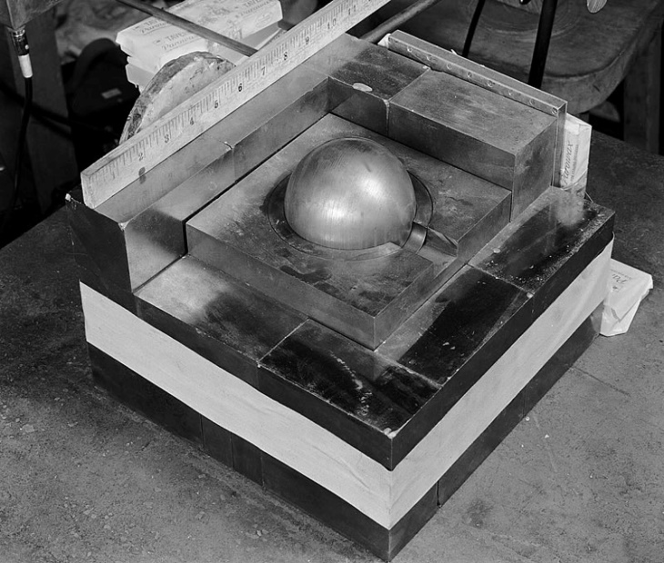

After World War II ended, The Demon Core was repurposed for testing and its purity (meaning the number of fissile nuclei) and design ensured it was “5% below critical” so that it was relatively safe. However, extraneous factors could bring this value to criticality or above. In the first incident such a factor occurred. Physicist Harry Daghlian was performing a series of neutron reflecting experiments, bringing a stack of neutron-reflecting tungsten carbide blocks towards the Core. With the addition of each block, bringing the Core closer and closer to criticality. Geiger Counters in close proximity measured the criticality by the detection of the products of the fission events.

While attempting to stack another brick around the assembly, Daghlian accidentally dropped it onto the Core causing it to go well into supercriticality; a self-sustaining critical chain reaction. He quickly moved the block off the assembly, but received a fatal dose

of radiation and died 25 days later.

In the second incident, Physicist Louis Slotin and seven other personnel were in the laboratory conducting another criticality experiment by slowly lowering a beryllium hemisphere shell over the top of the Core, the beryllium also acted as a neutron reflector and increased the criticality as it neared the Core. In what was later referred to as “unapproved protocol”, Slotin was slowly lowering the beryllium shell onto the Core with only a flat-head screwdriver held in his hand. Whilst he had done this maneuver a dozen times prior, on May 21, 1946, Slotin’s hand slipped, and the shell fell onto the assembly.

Instantly, there was a flash of blue light and a wave of heat was felt across Slotin's skin. He also experienced a sour taste in his mouth and an intense burning sensation in his left hand.

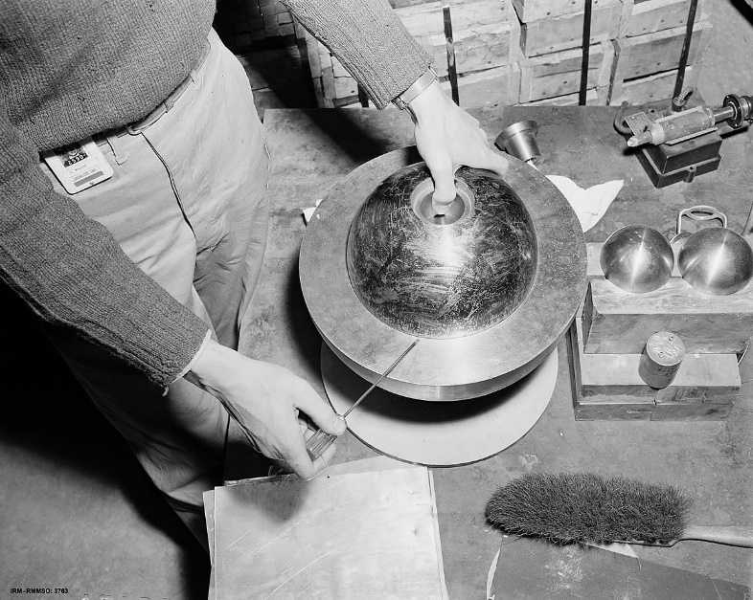

Image 2: The beryllium shell atop the Demon Core.

the core had become supercritical, releasing an immense burst of neutron radiation estimated to have lasted about a half second. Slotin quickly twisted his wrist, flipping the top shell to the floor ending the reaction. The position of Slotin's body over the apparatus also shielded the others from much of the fast neutron radiation, but he received a lethal dose of fast neutron and gamma radiation in under a second and died nine days later.

**Question 17** (continued)

The image below shows all of the possible interactions a neutron could have within a mass. Scattering refers to moving particles or radiation that are caused to deviate from a straight path due to interaction with other particles.

6. Nucleon

scattering

Free neutron

Reflector

Scattering

1. Escape 2. Scattering

4. Reflection

5. Fission

3. Absorption without fission

$$γ$$

$$γ$$

Image 3: The various modes of neutron interaction in a mass.

(a) Of the 6 modes of neutron interaction, place the numbers into the table that correspond to the effect on criticality.

(2 marks)

|  |  |
| --- | --- |
| **Increase** | **Decrease** |
|  |  |

(b) Explain why the Core was able to remain subcritical when sitting on its own.

(3 marks)

(c) Explain the role of the beryllium shell and the tungsten carbide blocks in relation to the criticality of the demon core.

(3 marks)

At the time of the accident, prescribed dosimetry film badges were in a locked box about 30 m from the accident. Realizing that no one in the room had their film badges on combined with Slotin knowing the severity of what had occurred, he ordered all of the personnel in the room to indicate where they were standing. This enabled the physicists to estimate the dose equivalent that each body had received.

Image 4: Approximate locations of personnel.

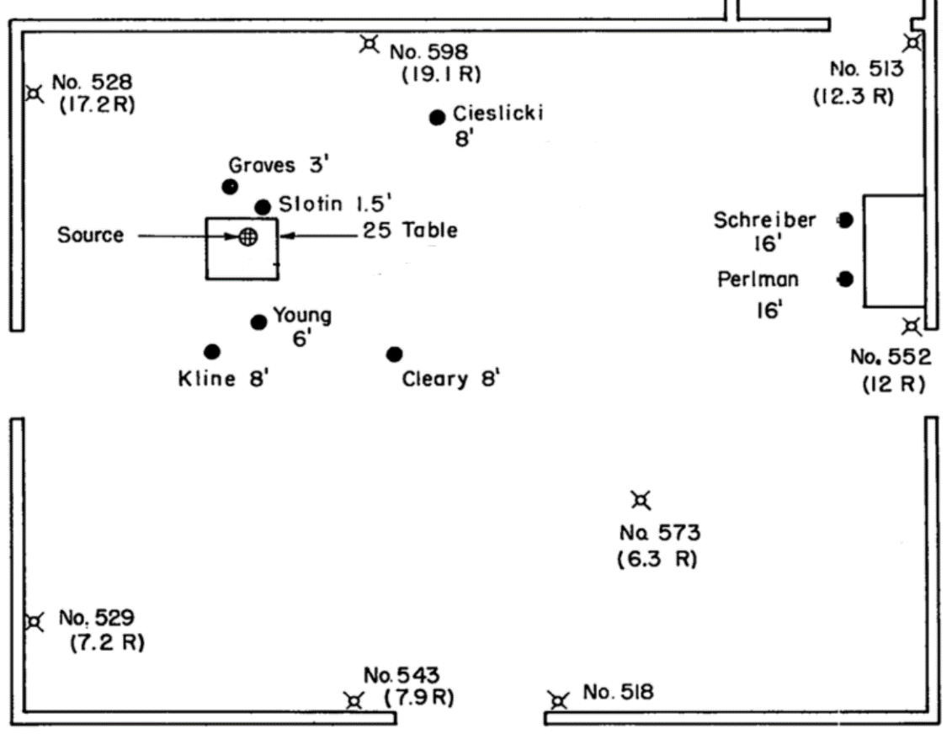

In the image above, the symbolsdenote a dosimetry counter that was present during the accident. The dose i.e. (7.9 R) is measured in Roentegen. 1 Roentegen is equal to 0.010 Sv.

**Question 17** (continued)

The table below shows an estimated summary and the subsequent health effects of the men.

|  |  |  |  |
| --- | --- | --- | --- |
| **Name** | **Profession** | **Dose (Gy)** | **Aftermath** |
| **Incident 1** | | | |
| Harry Daghlian | Physicist | 2.0 (fast neutron)  1.1 (gamma) | died 25 days after the accident of acute radiation syndrome |
| Robert Hemmerly | Army Guard | 0.080 (fast neutron)  0.001 (gamma) | died 33 years after accident of acute myelogenous leukemia |
| **Incident 2** | | | |
| Louis Slotin | Physicist | 10.0 (fast neutron)  1.14 (fast gamma) | died 9 days after the accident of acute radiation syndrome |
| Alvin Graves | Physicist | 1.66 (fast neutron)  0.26 (gamma) | died 19 years after in skiing accident |
| Marion Cieslicki | Physicist | 0.12 (fast neutron) 0.040 (gamma) | died 19 years later of acute myelocytic leukemia |
| Raemer Schreiber | Physicist | 0.090 (fast neutron) 0.030 (gamma) | died 52 years after the accident of natural causes |
| Theodore Perlman | Engineer | 0.070 (fast neutron) 0.090 (gamma) | died 42 years after the accident of natural causes |

(d) Calculate the Dose Equivalent of Louis Slotin,

(3 marks)

Theodore Perlman received a lower dose equivalent and did not suffer the effects of acute radiation sickness.

(e) Making reference to Image 4, explain why Perlman received a lower dose.

(2 marks)

**End of Questions**

Supplementary page

Question number: ____________

_________________________________________________________________________________________________________________________________________________________________________________________________________________________________________________________________________________________________________________________________________________________________________________________________________________________________________________________________________________________________________________________________________________________________________________________________________________________________________________________________________________________________________________________________________________________________________________________________________________________________________________________________________________________________________________________________________________________________________________________________________________________________________________________________________________________________________________________________________________________________________________________________________________________________________________________________________________________________________________________________________________________________________________________________________________________________________________________________________________________________________________________________________________________________________________________________________________________________________________________________________________________________________________________________________________________________________________________________________________________________________________________________________________________________

Supplementary page

Question number: ____________

_________________________________________________________________________________________________________________________________________________________________________________________________________________________________________________________________________________________________________________________________________________________________________________________________________________________________________________________________________________________________________________________________________________________________________________________________________________________________________________________________________________________________________________________________________________________________________________________________________________________________________________________________________________________________________________________________________________________________________________________________________________________________________________________________________________________________________________________________________________________________________________________________________________________________________________________________________________________________________________________________________________________________________________________________________________________________________________________________________________________________________________________________________________________________________________________________________________________________________________________________________________________________________________________________________________________________________________________________________________________________________________________________________________________________

Supplementary page

Question number: ____________

_________________________________________________________________________________________________________________________________________________________________________________________________________________________________________________________________________________________________________________________________________________________________________________________________________________________________________________________________________________________________________________________________________________________________________________________________________________________________________________________________________________________________________________________________________________________________________________________________________________________________________________________________________________________________________________________________________________________________________________________________________________________________________________________________________________________________________________________________________________________________________________________________________________________________________________________________________________________________________________________________________________________________________________________________________________________________________________________________________________________________________________________________________________________________________________________________________________________________________________________________________________________________________________________________________________________________________________________________________________________________________________________________________________________________

**Spare grid for graph**

